Simulation of Forward Curves and Spot Prices
Hannah Jabri
August 1, 2006

Forward Curve
Our model adopts a multi-factor approach to describe the evolution of the forward curve. The assumption is that forward prices with different maturities are driven by different stochastic processes. These latter processes are often referred to as the volatilities functions since they constitute the covariance matrix of the forward curve. The forward price evolution is given by the following process:
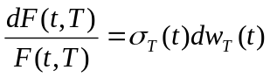 (Eq. 1)
where F(t, T) denotes the price at time “t” of a futures contract with maturity “T”, 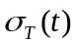 the volatility of F(t, T) and 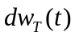 a Brownian motion.
We adopt a Principal Component Analysis (PCA) to estimate the covariance matrix, and therefore the volatilities functions of the forward curve. Each volatility function could be viewed as a risk factor, which tends to “shift”, “tilt”, or “bend” the forward curve. The first factor is either positive or negative for all maturities, implying that a shock to the system affects the forward curve in the same manner. The “tilting” factor causes the short and long term maturities to react differently. The third most important factor is the “bending factor” which causes the middle section of the forward curve to react to the opposite movements of short and long term maturities. Three factors do not always suffice to describe the variation of the covariance matrix. It is necessary to look at its eigenvalues and their contribution to the variability of the forward curve.
For a given set of futures contracts, (e.g. Aug06 till Jan07), we estimate the covariance matrix of their historical log-returns. PCA requires the estimation of the eigenvalues and eigenvectors of the covariance matrix. Rewriting (Eq. 1) gives,
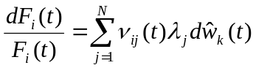 (Eq. 2) where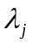 is the squared root of the j^{th} risk factor, 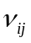 is its corresponding eigenvector and 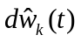are independent Brownian motions. Also for simplicity, we replaced “T” by “i” =1…N, which denotes the delivery month.
Upon examining the eigenvalues, one can determine the number of factors, n << N, required to explain a certain level of variation of the forward curve, say 96%. It should be added that each eigenvalue is the variance of its corresponding principal component. Therefore, the variation explained by the first 3 factors is the sum of the first three eigenvalues divided by the total sum of all eigenvalues.
Applying Ito’s lemma to (Eq. 2) with n factors gives:
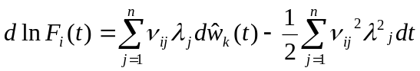 (Eq. 3)
The simulation of the forward curve is based on the discretized solution of (Eq. 3).
Additionally, we provide seasonal PCA eigenvalues and eigenvectors according to the seasons of the simulated pricing dates. For more details, please refer to the R file “FC.PCA.Fncs.r“, which simulates the forward curves based on seasonal PCA. For a concrete example, please see “FC.PCA.example.r”. Both files are found in the directory “S:\Risk\Temporary\PCA”

FEA User Guide, Technical Reference, page 62.

